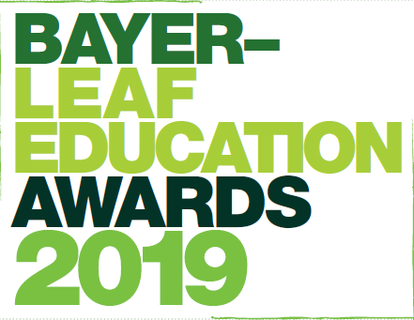

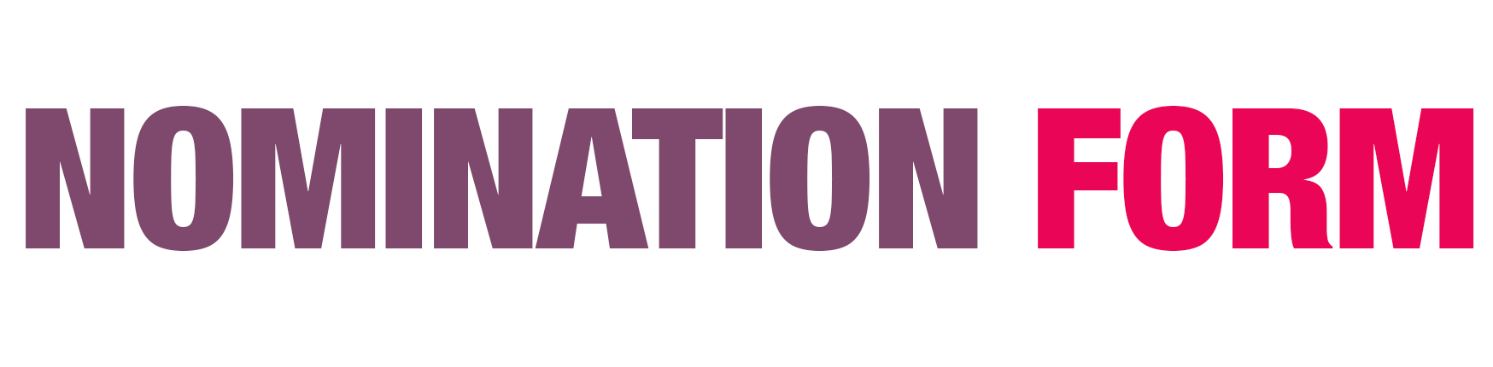
The Bayer-LEAF Education Awards celebrate the very best of agricultural education initiatives on-farm, in the classroom, or online.
If you know someone who goes that extra mile to share their passion for food and farming deserves to be recognised for their exceptional work in education, consider nominating them for an Award.
Visit cropscience.bayer.co.uk/Awards-2019 for more information
Your name:
Your address:

Your email address:
Your organisation/school (as appropriate):
Name of the person you are nominating:
Address of the person you are nominating:

Email for the person you are nominating:
Which Award category is the nomination for?
How do you know the person you are nominating?

Why do you feel they deserve this award?
(max 500 words)

Please return completed form to: education@leafuk.org by the 21st March 2019
Note: Bayer/LEAF Education will contact the person nominated with a request to complete an entry form providing fuller details of their work. We will inform the person nominated that you have recommended them for an award.
Your recommendation will be taken into consideration as part of the judging process.

Privacy Policy:
LEAF Education takes your privacy seriously and will not share the content of this form, including your personal details, with third parties including Bayer Crop Science. We have reviewed our Privacy Policy following the GDPR regulations introduced last year and it can be viewed here.

Innovative Learning Award
The Innovative Learning Award recognises a farm demonstrating innovative work with schools encouraging an understanding of and interest in current farming practices. Whether that’s utilising technology, thinking creatively about showing modern, sustainable farming or raising awareness of on-farm innovation. We are looking for an outstanding farm education initiative that really showcases modern sustainable farming.
Primary School Partnership Award
If you know a farm that has built and continues to build a successful relationship with primary schools (5-11 year olds) and makes a valuable and sustained contribution to school life, both on and away from the farm, then consider nominating them! We are looking for creative partnerships that are making real and lasting differences to young children’s understanding of farming and where their food comes from.
Secondary School Partnership Award
The Secondary School Partnership Award shines a spotlight on a farm business that has gone out of its way to build a successful relationship with one or more secondary schools (11-18 years old). We are looking for a farm business that is working with young people in new and imaginative ways to engage them with farming and helping to ignite their interest in the natural world. We’ll be looking for projects that are making a valuable and sustained contribution to school life on and away from the farm
Young Inspirational Communicator Award
Brand new this year, the Young Inspirational Communicator Award recognises an individual (between the ages of 18-35) that engages with young people to open their eyes to the world of farming, what it delivers, and why it matters using digital tools to do so. Chosen through a public vote, we are looking for an outstanding individual who is making a difference to how young people view farming and its role in their everyday lives through innovative digital methods. We will be looking for exciting and innovative projects that are addressing a particular educational challenge, or knowledge gap.

